**AN AI-BASED APPLICANT TRACKING SYSTEM**

**“HIREHUB”**

**Batch 2024**

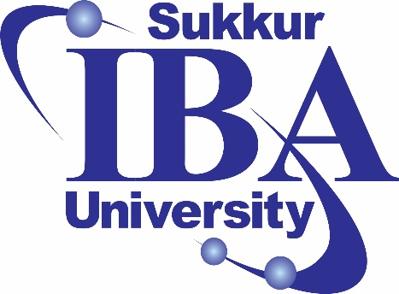

Student 1: - Vishaka Pahuja Roll# 023-21-0344

Student 2: - Mohammad Yaqoob Roll# 023-21-0335

Supervisor: Sir Rizwan Abro

**Sukkur IBA University**

**Department of Computer Science**

Table of Contents

**ABSTRACT 2**

**1.0 INTRODUCTION AND BACKGROUND 3**

**2.0 PROBLEM STATEMENT 3**

**3.0 OBJECTIVES: 4**

**4.0 METHODOLOGY: 4**

**4.1 ARCHITECTURE DEVELOPMENT 5**

**4.2 IMPLEMENTATION 5**

**4.3 WEBSITE DEVELOPMENT 6**

**5.0 CONCLUSION: 6**

**6.0 WORK FLOW CHART 6**

**6.1 ACTIVITY FOR USER WORKFLOW 6**

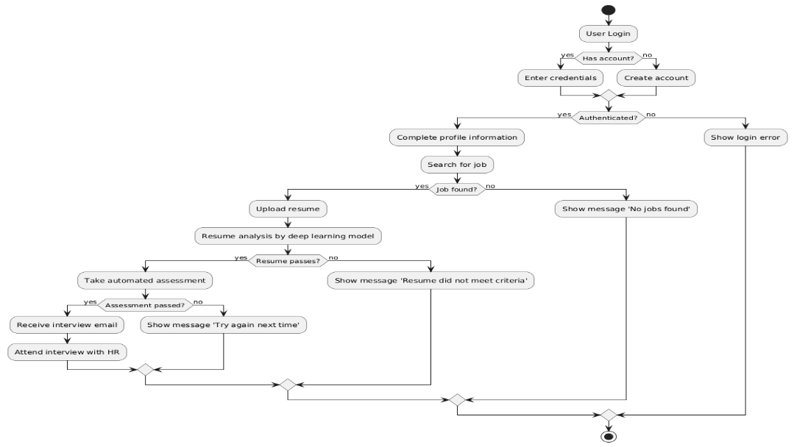 **6**

**6.2 ACTIVITY FOR HR WORKFLOW 7**

7](#_Toc181743523)

# ABSTRACT

Hiring new employees can be slow, inconsistent, and resource intensive. Recruiters often struggle with sorting through large numbers of resumes, managing time effectively, and keeping track of applicants. This can lead to delays, missed opportunities, and difficulties in the selection process. To address these challenges, this project involves creating a comprehensive website that leverages advanced AI technologies to streamline the hiring process. The website will automatically process and analyze resumes using Natural Language Processing (NLP) and machine learning algorithms. Candidates will be scored based on their qualifications, and AI-generated job-specific assessments will further evaluate their suitability for the role. After evaluating candidates, the system ranks them, provides instant feedback, and selects the top performers for interviews. By automating these tasks, the system helps recruiters manage time better and reduces resource usage. It also improves applicant tracking by keeping all candidate information organized and accessible. This AI-based ATS aims to eliminate human biases, reduce delays, and improve the credibility and accountability of the HR department. This project not only addresses the common challenges faced in recruitment but also aligns with the growing trend towards automation and AI in business processes.

# INTRODUCTION AND BACKGROUND

As technology advances, the departments of human resource in industries feel pressure to increase their performance when it comes to the hiring of employees. In the past, hiring activities have been done through resume review, subjective selection, and multiple administrative tasks that lead to long periods of recruitment, increased possibilities of bias, and increased possibility of bias and inconsistency in the selection process. These difficulties are compounded by the volume of application when the organizations grow and receive many applications that it is hard for them to recruit fairly and efficiently.

The ability to screen and evaluate applicants through an AI-Based Applicant Tracking System(ATS) come with a solution to these problems. An AI-Based ATS can assess candidates by analyzing their resumes, conducting online aptitude tests, and ranking applicants based on pre-defined criteria. By integrating machine learning(ML) models and natural language processing(NLP), this system is capable of assessing candidates’ skills and experience and decide whether or not they should be invited for the interview and without involving a recruiter at all, thus reducing bias and saving considerable amounts of time for screening.

The suggested project aims at the increasing demand for the automatic solutions in the companies’ HR departments, that causes high recruitment volumes, both for the large companies that need to solve a wide range of tasks in recruitment and for the companies that want to optimize their work in this sphere. With the help of this ATS solution, the HR teams will retain the highest levels of transparency and accountability and simultaneously disengage from spending time on routine tasks.

# 2.0 PROBLEM STATEMENT

Appointments in many organizations are time-consuming and subjective, expensive and ineffective processes that affect the ability of HR departments to effectively identify and make the right talent acquisition. As the number of applications for jobs continues rising, screening and evaluating applicants as well as choosing the best candidates takes time and results into immense workloads, delays and high turnover rates. In addition, traditional methods of recruitment tend to involve biases that may be unconscious and therefore, put-off the chances of the candidates from being selected fairly.

Studies indicate that over 70% of organizations worldwide receive more applications than they can efficiently process, with some estimates suggesting that screening a single resume can take up to seven minutes. Given that companies might receive hundreds or thousands of applications per vacancy, the cumulative time invested in manual screening is significant, increasing operational costs and delaying hiring decisions. Furthermore, biased hiring practices have been shown to impact workforce diversity and affect company reputation, as evidenced by surveys reporting that 48% of employees prefer workplaces with transparent and unbiased hiring processes.

The shortcomings of the traditional system can be met by the newly proposed AI-Based Applicant Tracking System (ATS) due to its ability to screen, test as well as rank the applicants. This helps HR teams save time, which they would otherwise spend on the initial assessments of the candidates so they can manage a greater volume of candidates and make more strategic contribution. This solution will be of value to any company that aims at improving its recruitment processes, reduce bias and gain a competitive edge through improving talent acquisition process.

# 3.0 OBJECTIVES:

Automate CV Analysis: Implement AI-powered parsing techniques to efficiently extract and analyze key data from CVs, reducing the time and effort required for manual review and improving data accuracy.

Conduct Candidate Assessments: Integrate online testing capabilities for shortlisted candidates to assess relevant skills and competencies, providing a standardized and objective measure of candidate abilities.

Streamline the Recruiter and Candidate Experience: Provide a user-friendly interface that simplifies interactions for both recruiters and candidates, facilitating easy navigation, application tracking, and data review. This interface aims to minimize friction in the hiring process, helping recruiters efficiently manage applications and candidates to engage with the system seamlessly.

# 4.0 METHODOLOGY:

The methodology for developing the **AI-Based Applicant Tracking System (ATS)** adopts a systematic approach that encompasses architecture development, implementation, and web application development. This methodology emphasizes creating a robust system architecture to facilitate efficient data flow and communication between components while ensuring scalability for future enhancements. The implementation phase focuses on developing AI models for CV scanning, predictive analytics, and integration with existing HR systems, followed by rigorous testing and optimization. The web application development process involves defining specific features and designing an intuitive user interface for real-time monitoring of applicant data, predictive insights, and management of the hiring process. Overall, the methodology aims to streamline the hiring process, reduce bias, and empower HR departments with data-driven insights for informed decision-making.

.

## 4.1 Architecture development

* + 1. **System Architecture Design:**
       - 1. Technology Selection: Choose appropriate technologies, frameworks, and AI models (e.g., Natural Language Processing, Decision Trees) based on project requirements.
         2. Integration Plan: Develop a comprehensive plan for integrating the ATS with existing HR systems and databases to ensure seamless data exchange and process automation.
    2. **Data Source Identification:**
       - 1. Identify Data Sources: Determine the various sources of applicant data, including resumes, application forms, and assessments.
         2. Data Collection: Implement processes to gather data from these sources for analysis and model training.
    3. **System Configuration:**
       - 1. Database Design: Design a database schema to store applicant information, resumes, and related metadata efficiently.
         2. User Role Management: Establish user roles and permissions for HR personnel to manage the hiring process securely.

## 4.2 Implementation

* + 1. **AI Model Development:**
       - 1. Data Collection: Clean and preprocess the collected data to ensure quality and relevance for training AI models.
         2. Model Training: Utilize machine learning techniques to develop models for CV parsing, ranking applicants, and predicting candidate success based on historical data.
    2. **Predictive Analytics Implementation:**:
       - 1. Data Analysis: Implement AI-driven analytics to assess candidate suitability, predicting job performance based on historical data.
         2. Decision Support System: Develop a decision support system for HR teams that offers AI-generated insights to aid in the candidate selection process.
    3. **Testing and Validation:**

System Testing: Conduct comprehensive testing of the integrated ATS to ensure all components function correctly and efficiently.

## Website Development

* + - * 1. Feature Specification: Define the specific functionalities that the website will offer, such as real-time monitoring of applicant status, notifications for new applications, analytics dashboards for HR metrics, and user management features for HR personnel.
        2. User Interface Design: Create an intuitive and visually appealing interface for the website that allows users to navigate easily.
        3. Frontend and Backend Integration: Ensure seamless integration between the frontend and backend systems to facilitate smooth data flow and user interactions.

5.0 Conclusion:

The **AI-Based Applicant Tracking System (ATS)** enhances hiring efficiency, transparency, and fairness by integrating AI for CV parsing, predictive analytics, and data-driven decision-making. Through careful system architecture design, AI model development, and web deployment, the ATS provides HR teams with an intuitive platform for real-time monitoring and applicant assessment. This solution not only accelerates candidate selection and reduces bias but also improves overall hiring outcomes, offering a scalable foundation for future enhancements. The **ATS** stands as a powerful tool for HR departments, empowering them to leverage AI for more effective and accountable hiring practices.

# 6.0 Work Flow Chart

## 6.1 Activity for User Workflow

## 

## 6.2 Activity for HR workflow

